# Technical FAQ (about testing)

## *Number of injected defects in the SUT*

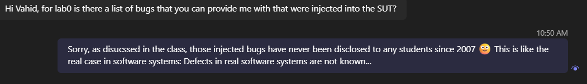

## *Can I make assumptions about the SUT, when I am testing?*

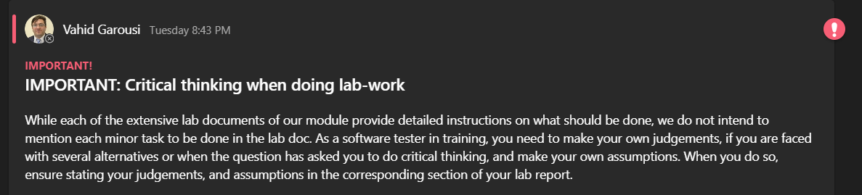

## *In a bank account: What's the difference between account balance and available balance?*

Account balance is made up of all posted credit and debit transactions. It's the amount that the customer has in the account before any pending charges are added. The available balance is the amount the customer can use for purchases or withdrawals.

You can read more on the internet: <https://www.google.com/search?q=available+balance+vs+account+balance>

## *"I haven’t had a chance to fully read the lab0 document yet, but are we looking at any code or is it just running the system and finding bugs?"*

We don't have access to the SUT's source code in this lab. We run the software to find defects.

## Do we keep the examples in the test plan headers and how detailed should the test plans be?

The lab doc says what items shall be included in the test plan. The plan should address those issues adequately.

## Should the test cases be listed in the test plan?

Froom the lab doc: *“Note: a test plan shall NOT contain test cases, but should discuss how you plan to derive/design test cases”*

## *RE: “How you plan to design the test cases (test most common paths, or exceptional/invalid paths, etc.):”* Do we need to select one of them types or all?

Answer:

* You should ideally assess the decision for each different module / feature of the SUT and choose the right decision for each.

## RE: “*How you plan to design the test cases (test most common paths, or exceptional/invalid paths, etc.)*” -- Would I need to develop my own test cases like the example in APPENDIX C?

Answer:

* The question is not asking to design the test cases, but your test “plan”. Two alternatives are already provided: *test most common paths, or exceptional/invalid paths*

## Hi, could you clarify what 'available' means on the receipt, in the SUT’s UI?

image

Please learn about the banking terms online:

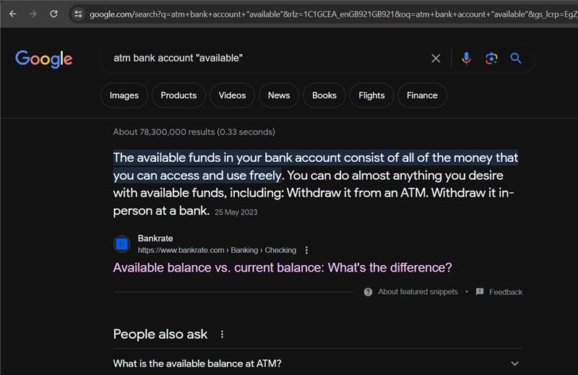

## Do we include the comment for duplicates in both bug reports in zoho or just change their states?

See the detailed insturctions in the lab0 doc

## Do we need to comment on the manual/regression testing in the report or is it just the counts and discussion on approaches etc. that are included in the report?

What the lab doc asks for is its headings and also marking scheme. Just provide those info

## Are there only 4 functions or are there more (i.e. withdrawal, balance, transfer and deposit)?

See the system’s use-case diagram in the Appendix

## Is the intro regarding manual scripted testing?

See many online resources on how to write introduction of a report: <https://www.google.com/search?q=introduction+of+a+report>

## Can we consider things that don’t logically make sense and not really mentioned in the spec a bug, or is it just based off what is written in the spec?

You should do your crticial thinking and make any reasonable assumptions, when necessary; and if you do so, you should write down your assumption in the report.

## Same bug report or not?

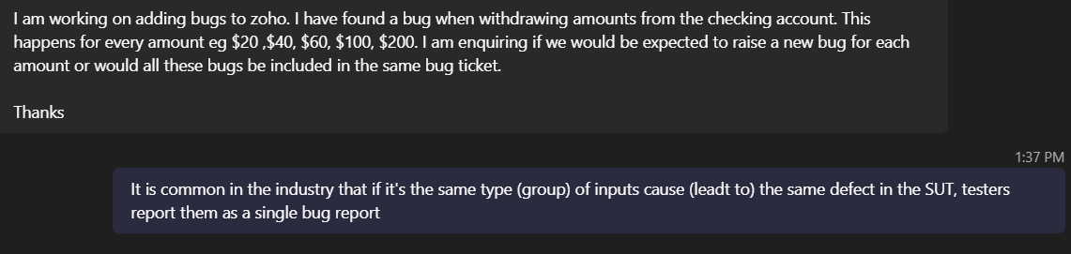

# Non-technical FAQ (Project set-up, etc.)

## Zoho set up

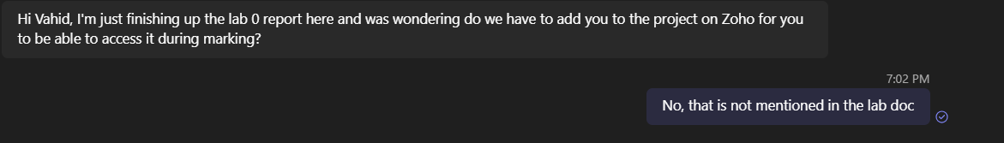

## Options of doing reduced lab-work for students working alone (not in a group):

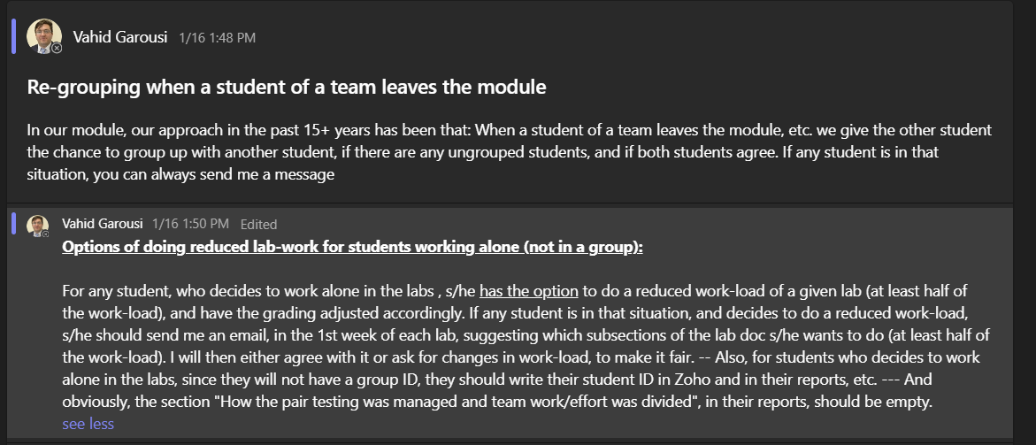

## Zoho’s short-term software license

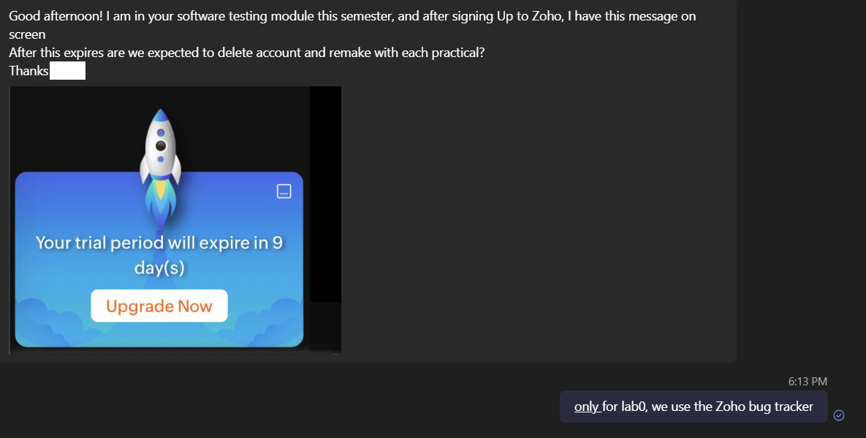

## When I run the ATM JAR file on my Mac machines, I get this error. Is there anyway to fix this?

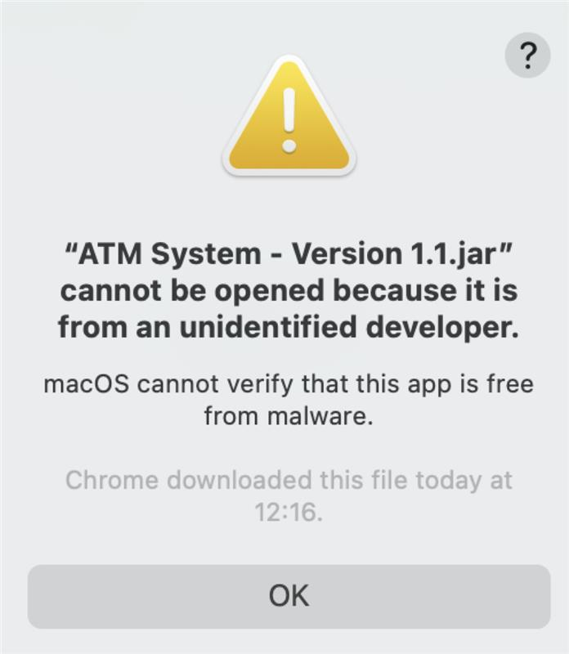

We have heard that this occurs sometimes on Mac machines. Note that all the university evironment and modules work are in Windows OS, and thus have we cannot provide help for Mac machines... But Google search can perhaps help you <https://www.google.com/search?q=mac+jar+files+unidentified>

## For the project and portal names what do we include if '-' isn’t allowed on zoho (as mentioned in pdf)?

It seems Zoho software has updated its validation rule-set recently. You can drop the “-”, so the portal name can be for example: “2024G51”

## Should we include references/list e.g. for the intro

Follow what the lab doc says. If it does not ask for something, it is optional and up to you (not required).

## Can we resubmit on canvas more than once before the deadline?

See the setting in Canvas. You can resubmit on canvas more than once before the deadline

## Is the link to zoho public?

See the setting in Zoho. If there is no such a feature, just leave the default. Screenshots from all bug reports shall be included in your report.

## Zoho Portal Naming RE: *I tried to create a portal with the naming convention "2024-G999", but this would not allow me to enter a hyphen or upper case letters , so I went with "2024g999". is that okay for the link [name]?*

Having a “-” in the Zoho portal/or project name is not a big deal. If Zoho does not allow it, it is OK not having “-”. Make sure you write a phrase that includes year and group number like 2024G99 or 2024Group99

## Submission of group’s lab work in Canvas

